**Practical No. 05**

**Aim: Working with the CircleCI**

**Create a Repository**

1. Log in to GitHub and begin the process to create a new repository.
2. Enter a name for your repository (for example, hello-world).
3. Select the option to initialize the repository with a README file.
4. Finally, click Create repository.
5. There is no need to add any source code for now.

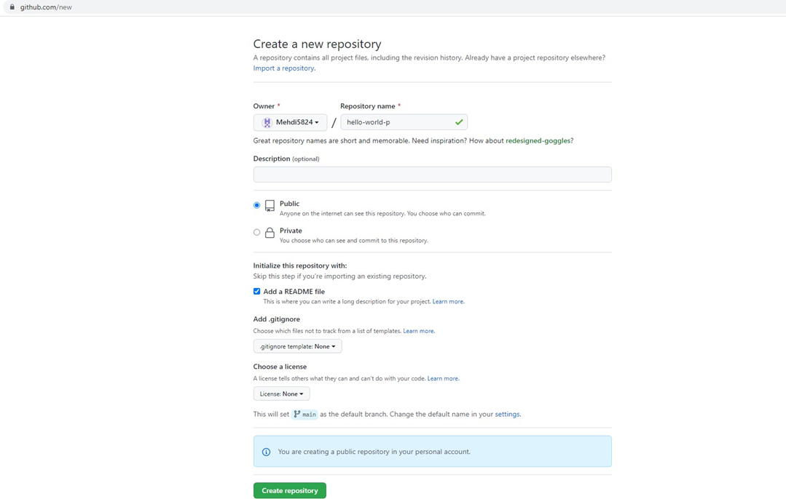

Login to Circle CI https://app.circleci.com/ Using GitHub Login, Once logged in navigate to Projects.

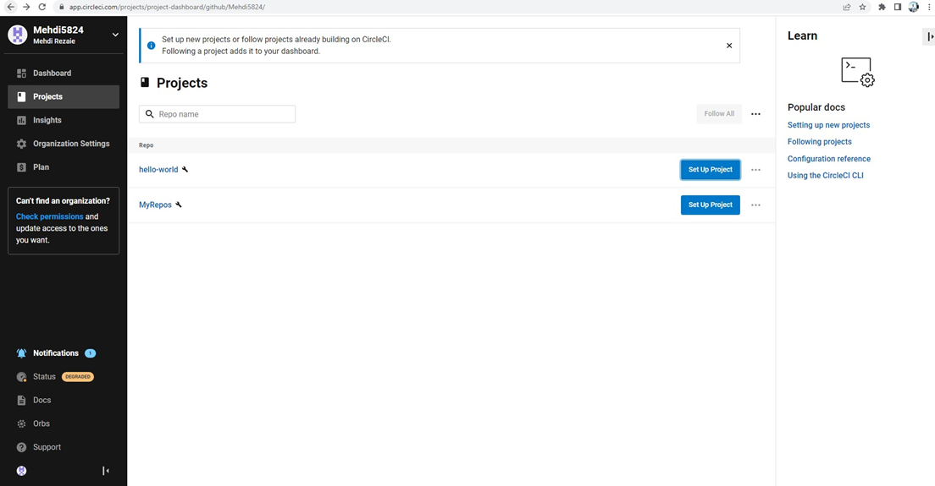

**Set up CircleCI**

1. Navigate to the CircleCI Projects page. If you created your new repository under an organization, you will need to select the organization name.
2. You will be taken to the Projects dashboard. On the dashboard, select the project you want to set up (hello-world).
3. Select the option to commit a starter CI pipeline to a new branch, and click Set Up Project. This will create a file

.circleci/config.yml at the root of your repository on a new branch called circleci-project-setup.

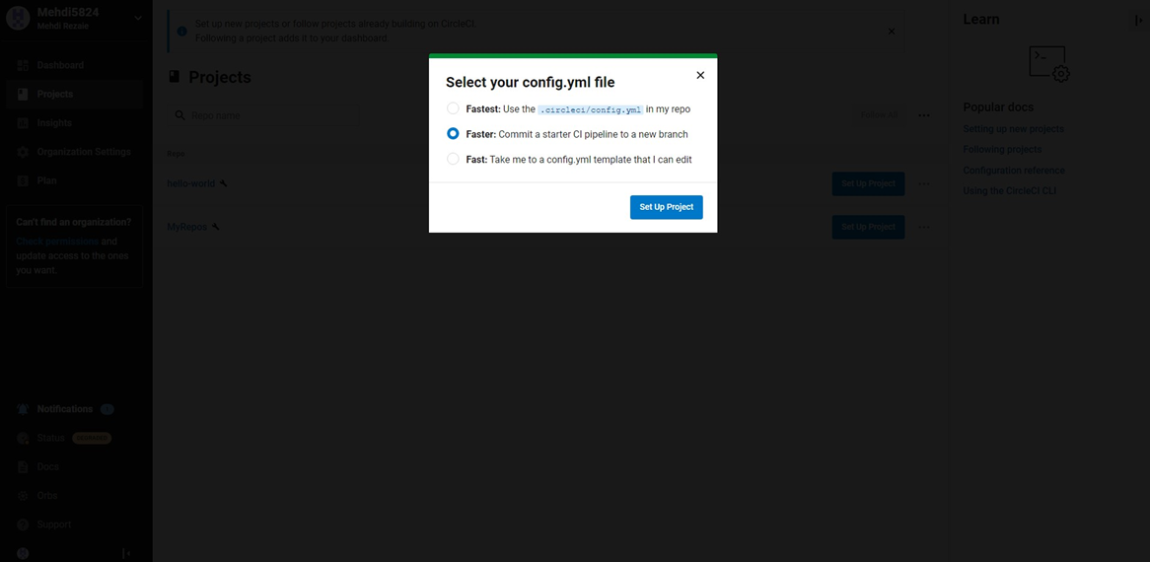

**Your first Pipeline**

On your project’s pipeline page, click the green Success button, which brings you to the workflow that ran (say-hello- workflow).

Within this workflow, the pipeline ran one job, called say-hello. Click say-hello to see the steps in this job:

1. Spin up environment
2. Preparing environment variables
3. Checkout code
4. Say hello

Now select the “say-hello-workflow” to the right of Success status column

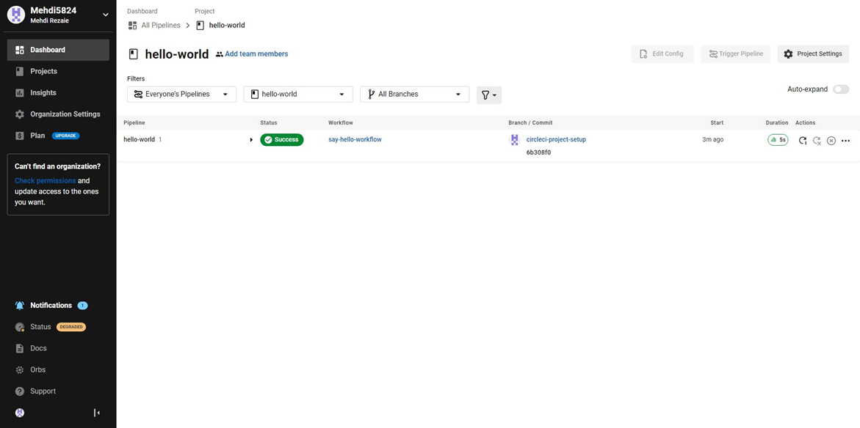

Select “say-hello” Job with a green tick

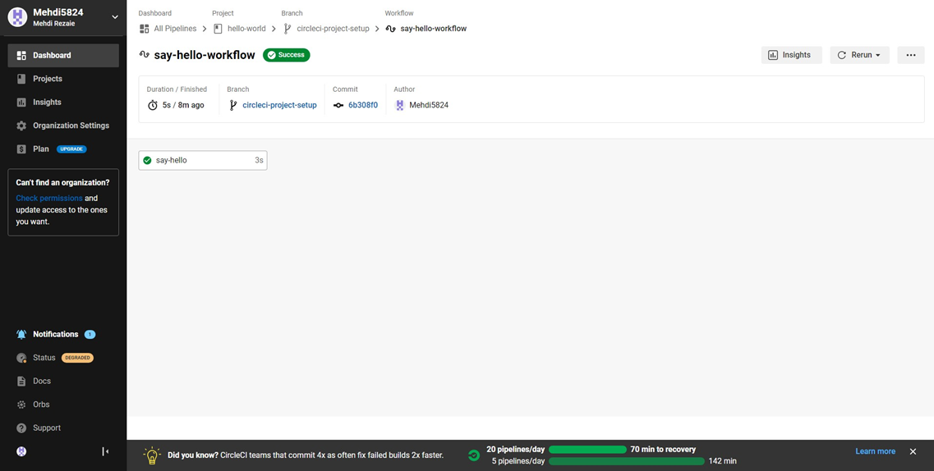

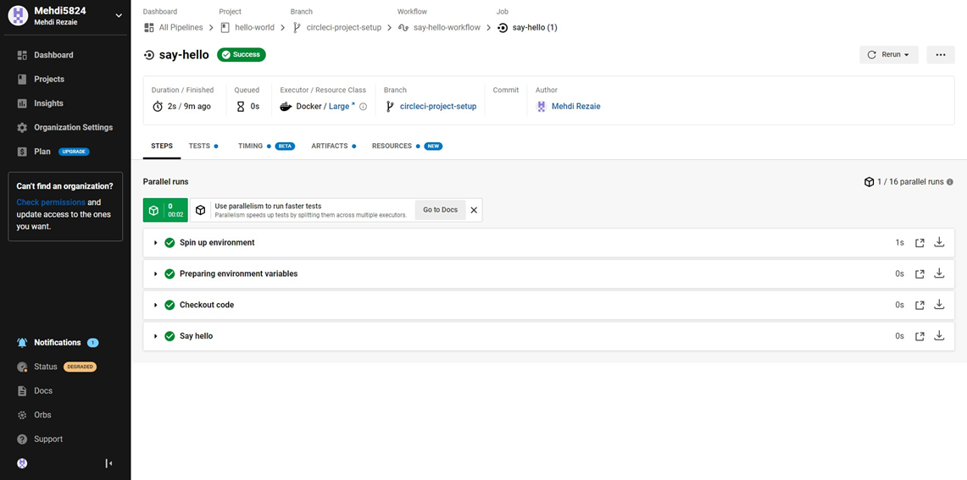

Select Branch and option circleci-project-setup

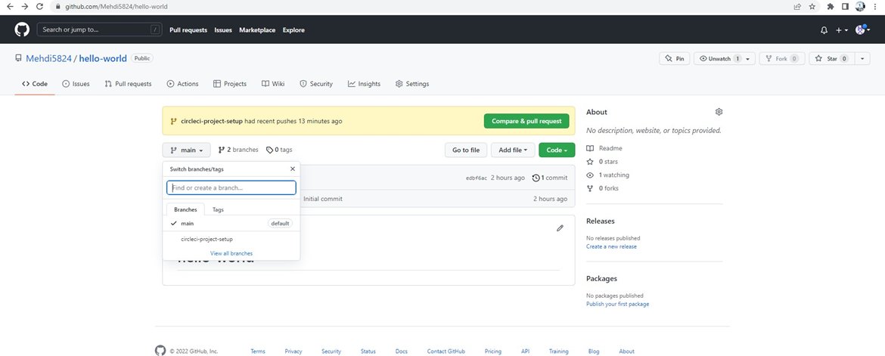

**Break your Build**

In this section, you will edit the .circleci/config.yml file and see what happens if a build does not complete successfully. It is possible to edit files directly on GitHub.

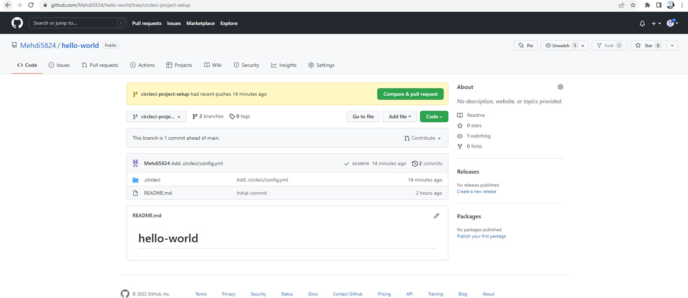

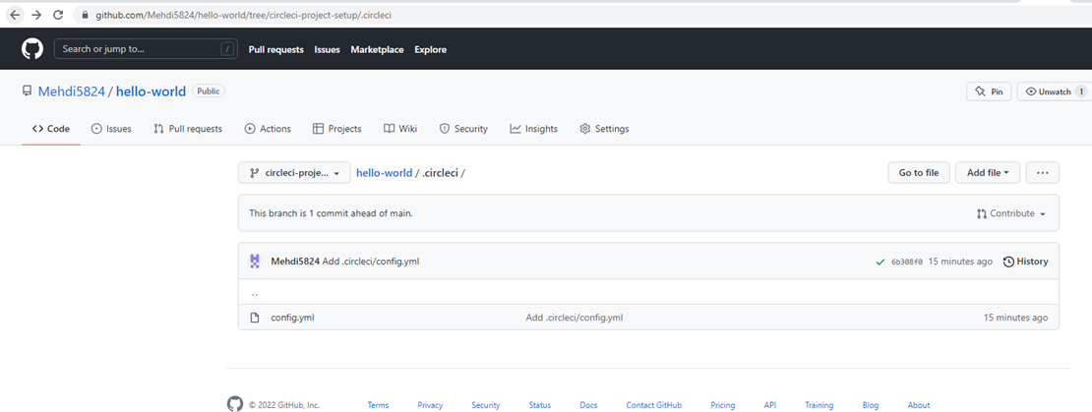

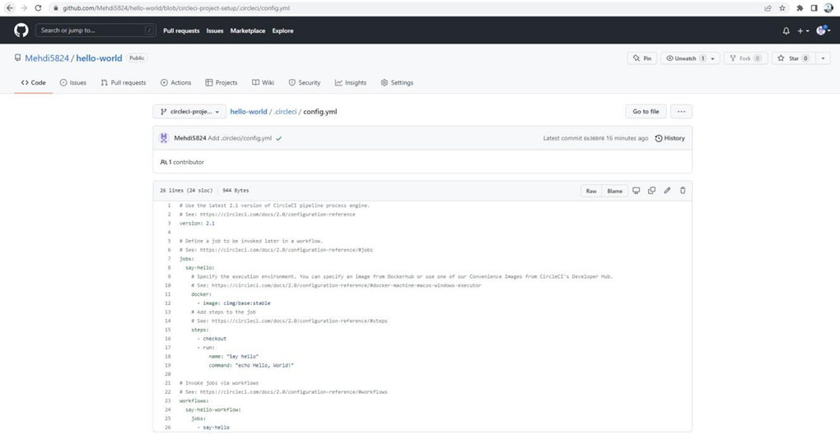

Let’s use the Node orb. Replace the existing config by pasting the following code:

version: 2.1

orbs:

node: cirlceci/node@4.7.0

jobs:

build:

executor:

name: node/default

tag: '10.4'

steps:

- checkout

- node/with-cache:

steps:

-run: npm install

-run: npm run test

The GitHub file editor should look like this

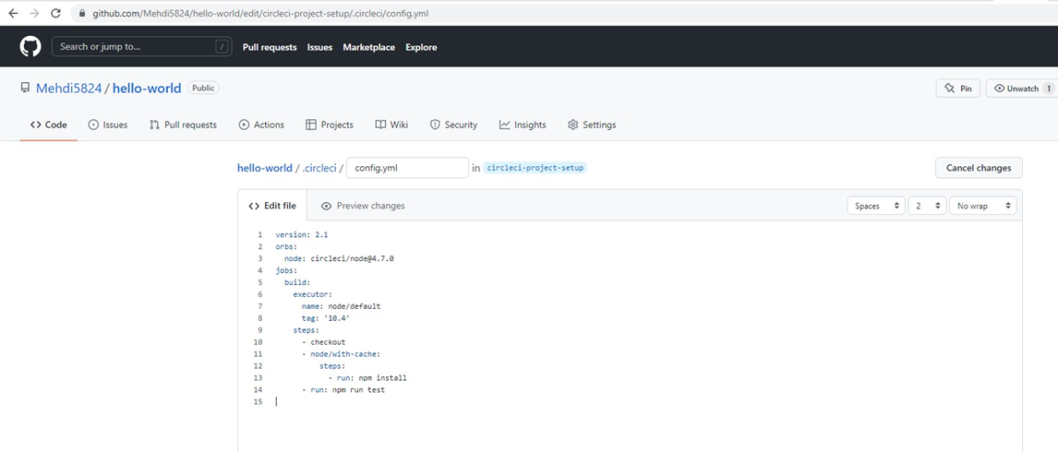

Scroll down and Commit your changes on GitHub

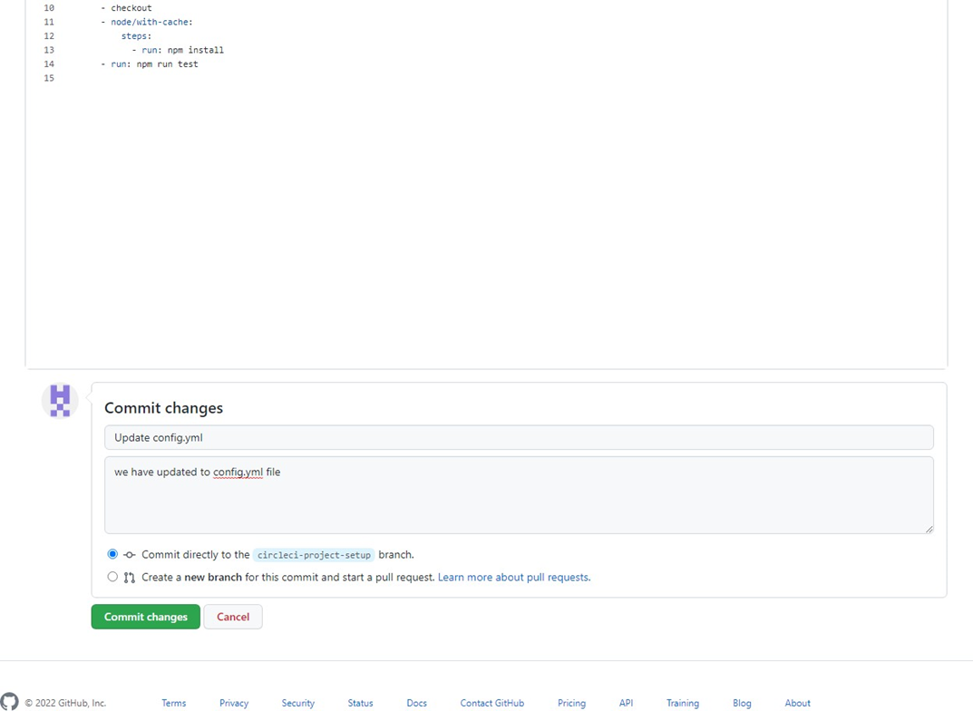

After committing your changes, then return to the Projects page in CircleCI. You should see a new pipeline running… and it will fail! What’s going on? The Node orb runs some common Node tasks. Because you are working with an empty repository, running npm run test, a Node script, causes the configuration to fail. To fix this, you need to set up a Node project in your repository.

